Topic 8 – Ratio analysis
Overview page
5/1/23
Financial statement analysis (which includes Ratio analysis ) is the process of analyzing financial and non financial reports in order to assess the financial and business status of firms. This analysis can include a variety of approaches that are designed to provide the analyst with insights related to asset mix, liquidity, solvency, capital structure, profitability, risk etc.

Ratio = Numerator / denominator
Basic steps to undertake ratio analysis
- Set objectives (e.g., What questions are you trying to answer?)
- Formulate ratio (identify the formula)
  - Note that the numerator and demoninator should measure related items
  - How to deal with a ratio that has an income statement item in numerator and balance sheet item in the denominator?
  - How to deal with a ratio if the denominator can equal zero?
- Find data and calculate the ‘ratio value’
- Interpret ratio value (Intuition related to mechanics): Standard approach is:
  - In general → For every one ‘denominator unit’ we have the ‘numerator’
  - So if ‘Current assets/ Total assets’ = $12,240/$31,616 = .387. We interpret this as follows: for every dollar of total assets, we have about $.39 of current assets.
- Draw inference from the ratio value (Use the ratios for further analysis)
  - What is a reasonable value? Is there an optimal value? Is bigger always better? What value(s) signify a red flag?
  - Determine comparable ratio value based on historical numbers, comparison groups such as peers or best in class
  - Note that ratios can be “managed,” for example (n-c)/(d-c) > n/d

Part 1: Terms and background
- Introductory issues
- Common-size financial statements -- Financial diagnostics of a firm
- Ratio analysis
  - Profitability
    - Return on assets - ROA
      - Profit margin on assets and asset turnover
    - Return on common equity - ROE
      - Profit margin on equity, asset turnover, and leverage
    - Earnings per share (EPS) and P/E and E/P ratios
- Accounts receivable turnover ratio – days in receivables
    - Inventory turnover ratio – days in inventory
    - Fixed asset turnover ratio
- Long-term risk ratios
- Limitations of ratio analysis

Part 3: Other topics
Part 1: Terms and background

Medical diagnosis similarities

Objectives of statement analysis
- To understand the economics of a firm and
- To help forecast its future profitability and risk
  - Profitability is an increase in wealth
  - Risk is the probability that a specific level of profitability will be achieved.
- Financial statement analysis (FSA) involves the examination of both the relationships among financial statement numbers, the trends in those numbers over time, and how compare to other firms
- Note: Different analysts use different formulas for ratios
- As an example of other formulas, see Hoover’s
http://www.hoovers.com/
http://premium.hoovers.com/subscribe/co/fin/comparison.xhtml?ID=11600

Parts of financial analysis
- Business analysis
- Industry analysis
  - Use macro and industry data/reports and other resources
  - Firm analysis: Drivers of competitive advantage and profitability
  - Use MD&A from firm’s 10-K and other resources
- Financial statement analysis
  - Cash flow analysis
  - Common-size and ratio analysis
  - Use firm’s financial statements and footnotes
- Accounting analysis
  - Quality of earnings and Earnings management
  - Use firm’s financial statements and footnotes

Illustration showing the effect of tax deductible expenses (assume full deductibility)
 | Without party | With party | Difference
Income before “party” and taxes | $ 20,000 | $ 20,000 | $0
Cost of party | 0 | 2,000 | -2,000
Income after party, before taxes | 20,000 | 18,000 | 2,000
Taxes (@40%) | 8,000 | 7,200 | 800
Income after taxes | 12,000 | 10,800 | 1,200

After tax impact of a expenditure = expenditure * (1- tax rate)

Reformatting the I/S to separate operating and financing – Stylized example
GAAP approach |  | Wall street approach
Revenue | $1,000 | Revenue | $1,000
- Operating expenses | 700 | - Operating expenses | 700
Operating income | 300 | Operating income b/4 taxes (EBIT) | 300
- Interest expense | 100 | - Taxes on OI (@40%) | 120
Income before tax | 200 | OI after taxes (NOPAT = EBIT*(1-tax rate)) | 180
 |  | - Interest expense = 100
- Taxes (@40%) | 80 | Tax savings on interest expense = 40
 |  | After tax cost of interest | 60
Net income | 120 | Net income | 120

Find standards against which to compare ratios
- The planned ratio for the period
- The corresponding ratio from a prior period
- The corresponding ratio for another firm in the same industry
- The average ratio for other firms in the same industry
- The average ratio for other “similar” firms (e.g., best in class)
- Places to find benchmark information
  - S&P industry survey
  - Analysts’ reports
  - Olin library data resources

Common-size financial statements

- Common-size financial statements show all amounts for a given year as a percentage of some measure, such as sales or total assets
- I/S (for current year or base year)
  - Each I/S account divided by total sales
  - Percentage change over time (not common-size)
- B/S (for current year or base year)
  - Each B/S account divided by total assets
  - Sales divided by each B/S account or averaged B/S account (turnover concept)
  - Percentage change over time (not common-size)

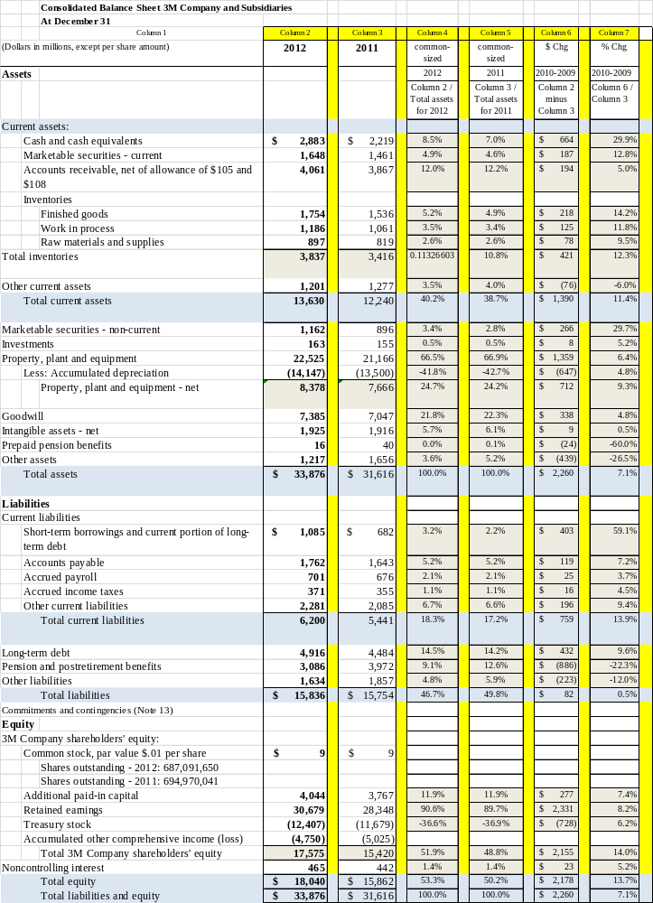
Return on assets (ROA): This ratio provides information about a firm’s operating performance. Operating performance is a measure of the use of assets to generate earnings independent of the financing of those assets.

ROA = NOPAT / Total assets

What is in the denominator? Get information from balance sheet

- Total assets = $33,876

What needs to be in the numerator to match? Get information from income statement

- NOPAT = Net operating profit after tax
  - Operating income*(1- τ ) = OI * (1- τ)
  - EBIT*(1- τ)
  - {Net income + Interest expense (1- τ)} → if there is only Interest expense

- OI = Operating income. OI for 3M for FY 2012 = $6,483

- τ = Tax rate = Tax provision/Taxable income. For 3M for FY 2012 = 29%
  - Tax provision = $1,840 (from 3M’S income statement)
  - Taxable income = $6,351 (from 3M’S income statement)
  - Tax rate = 29% = $1,840/$6,351

- NOPAT = Operating income (1-.29) = $6,483 * (1-.29)
$6,483* .71 = 4,603

3M’s ROA for 2012 and disagreggated calcualtions

ROA | = | 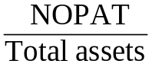 | = | 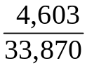 | = | 13.6

Disaggregated ROA | = | ROA profitability | * | Total asset turnover

Disaggregated ROA | = | 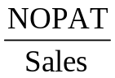 | * | 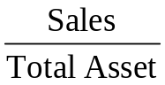
= | 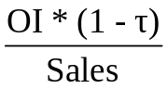 | *

Disaggregated ROA for 3M for 2012 | = | 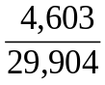 | * | 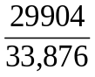 | = | 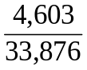 | = | 13.6%

Disaggregated ROA for 3M for 2012 | = | .15 | * | .883 | = |  | 13.6%

How can 3M increase ROA?

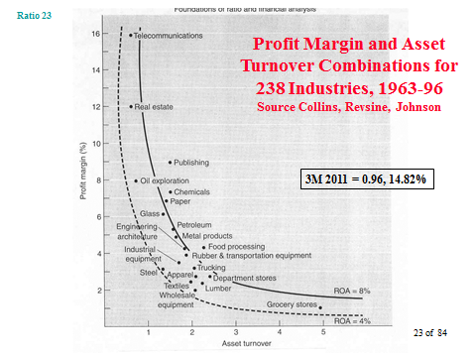

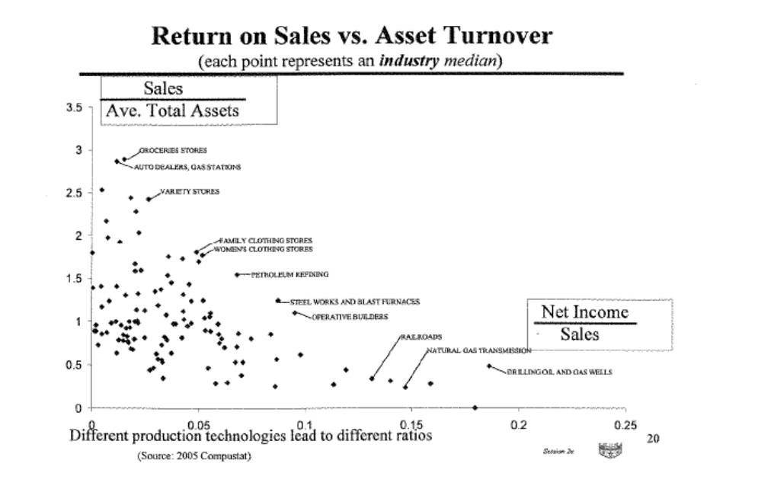
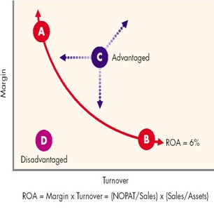
How to interpret
  - Firms A and B earn the same ROA, but in different ways
    - Firm B is low cost competitor
    - Frim A follows a differentiated strategy
    - Both earn at the “competitive floor”
  - Point C earns an ROA about the floor
  - Firm D earns below the floor
  - Leverage
Distinguish operating from financial leverage

Operating leverage relates to the impact on operating income due to a change in the level of output (use of fixed costs to substitute for variable costs).

Financial leverage relates to the mix of liability and equity to finance the acquisition of assets. Leverage can effect ROE

Favorable financial leverage exists if:

ROA > After tax cost of debt.

That is, ROE increases if ROA > after tax cost of debt

Assets = Liabilities + Stockholders’ equity

Assets = Liabilities + contributed capital + retained earnings

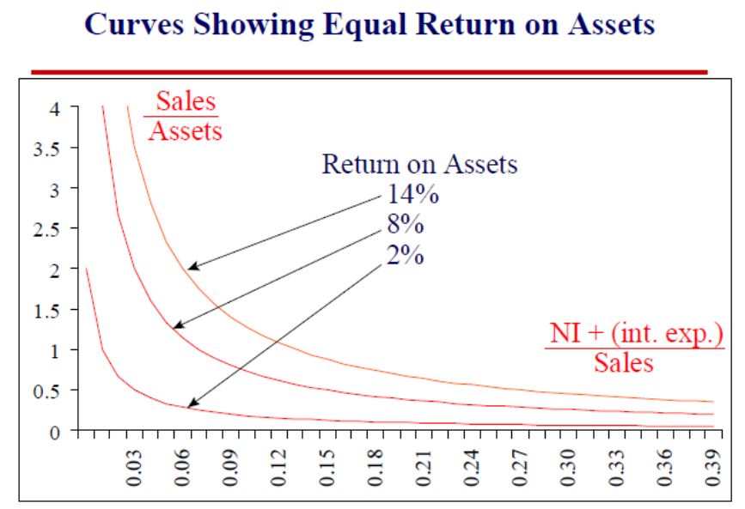

Illustration showing the effect of financial leverage – house purchase

 | No leverage | Leverage
Cost of house on acquisition date (1/1/01) | $200,000 | $200,000
Owner’s stake | 200,000 | 40,000
Banker’s stake (@ 4% per year) | 0 | 160,000
Interest = ($160,000*.04) = |  | 6,400
House value on 1/1/02 | $220,000 | $220,000
Return (No leverage → 220,000-200,000 = 20,000  And leverage → 220,000-160,000-40,000-6,400 = 13,600 | 20,000 | 13,600
Rate of return 20,000/200,000 = 10% and  13,600/40,000 = 34% | 10% | 34%

Return on equity (ROE): This ratio provides information about a firm’s performance in using shareholders’ equity (denoted as SE) to generate value. Return that management has earned on the capital that is actually owned by
common shareholders, which depends on leverage.

What is in the denominator?

What needs to be in the numerator to match?

ROE: various approaches that are equivalent (generally)
- ROE = Net income / Equity
- Dupont analysis – disaggregation of ROE

Notation and Definitions

- NI = Net income. NI for 3M for FY 2012 = $4,511

- Equity = $18,040

3M’s ROE for 2012 and disagreggated calculations

Dupont analysis

Disaggregated ROE | = | ROE  Profitability | * | Total asset  turnover | * | Leverage

ROE | = | 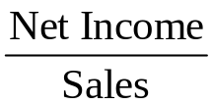 | * | 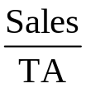 | * | 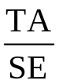

ROE | = | 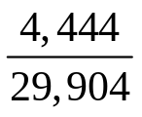 | * | 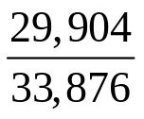 | * | 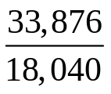 | = | 24.6%

ROE | = | .149 | * | .883 | * | 1.88 | = | 24.6%

Interpretation?
How can 3M increase ROE?
How is ROA related to ROE

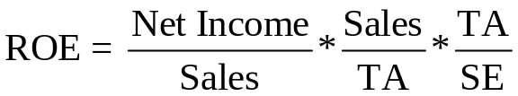

ATCD = after tax cost of debt (measure as an interest rate %)

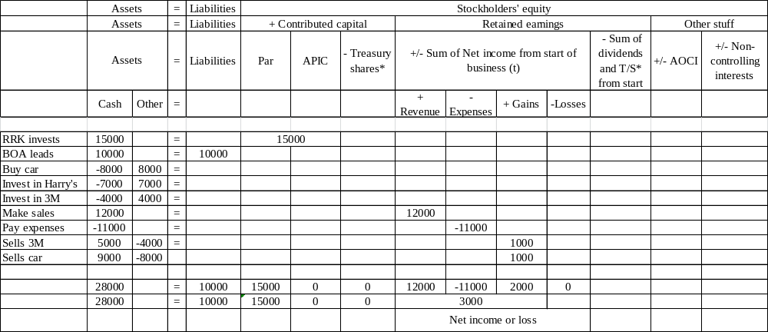

Capital Structure of 3 Firms
 | Firm A | Firm B | Firm C
Total Assets | $8,000,000 | $8,000,000 | $8,000,000
Total Debt | $2,000,000 | $4,000,000 | 0
Total Equity | $6,000,000 | $4,000,000 | $8,000,000
Total Capital | $8,000,000 | $8,000,000 | $8,000,000
Interest Rate on Debt | 10% | 10% | 10%
Tax rate | 35% | 35% | 35%

ROA & ROE for Firm A
Effect on Firm A | ROA = 3.25% | RPA = 6.5% | ROA = 9.75%
Operating Income | $400,000 | $800,000 | $1,200,000
Interest Expense at 10% | 200,000 | 200,000 | 200,000
Income Before Taxes | 200,000 | 600,000 | 1,000,000
Income Tax Expense at 35% | 70,000 | 210,000 | 350,000
Net Income | $130,000 | $390,000 | $650,000
ROE = Net Income/Equity | 2.2% | 6.5% | 10.8%
ROA = NOPAT/Assets | 3.25 | 6.5 | 9.75
NOPAT = | 260,000 | 520,000 | 780,000

ROA & ROE for Firm B
Effect on Firm B | ROA = 3.25% | RPA = 6.5% | ROA = 9.75%
Operating Income | $400,000 | $800,000 | $1,200,000
Interest Expense at 10% | 400,000 | 400,000 | 400,000
Income Before Taxes | 0 | 400,000 | 800,000
Income Tax Expense at 35% | 0 | 140,000 | 280,000
Net Income | $0 | $260,000 | $520,000
ROE = Net Income/Equity | 0.0% | 6.5% | 13.0%
ROA = NOPAT/Assets | 3.25 | 6.5 | 9.75

ROA & ROE for Firm C

Effect on Firm C | ROA = 3.25% | RPA = 6.5% | ROA = 9.75%
Operating Income | $400,000 | $800,000 | $1,200,000
Interest Expense at 10% | 0 | 0 | 0
Income Before Taxes | 400,000 | 800,000 | 1,200,000
Income Tax Expense at 35% | 140,000 | 280,000 | 420,000
Net Income | $260,000 | $520,000 | $780,000
ROE = Net Income/Equity | 0.0% | 6.5% | 9.75%
ROA = NOPAT/Assets | 3.25 | 6.5 | 9.75

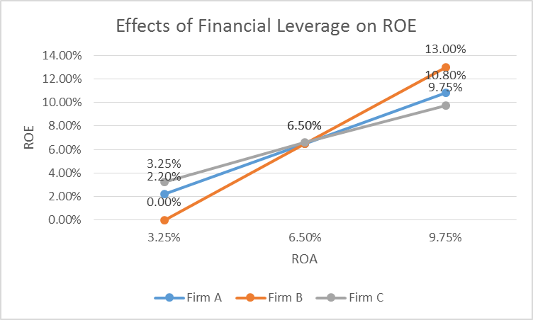
Four steps to calculate “days in financing”

Step #1: Inventory turnover for 3M for 2012: How quickly a firm sells its inventory?

Inventory Turns = COGS / Inventory

4.09 times = 15,685/3837

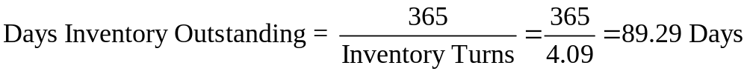

Days inventory outstanding = 363/inventory turns = 365/4.09 = 89.29

Step #2: A/R Turnover for 3M for 2012: How quickly a firm collects its cash?

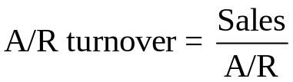

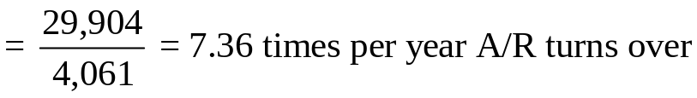

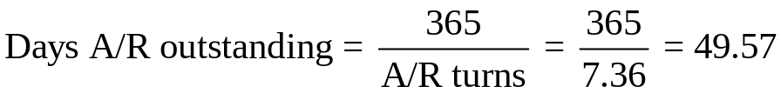

Step #3: Accounts payable turnover / ‘days in payables’ for 3M for 2012: How quickly does the firm pay its receivables?

Purchases = COGS + Ending inventory – beginning inventory
16,106 = 15,685 + 3,837-3,416

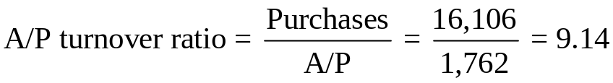

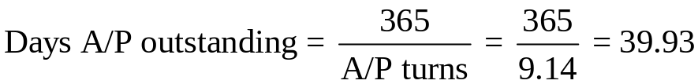

Step #4: Calculate days in financing
89.29+49.57-39.93=98.93= days in financing of WC
Days in inventory + days in receivable – days in payables = days in financing

Working capital turnover ratios (for 2012)
(aka: cash to cash cycle or days in financing of WC)

Purchase
inventory
Sell
inventory
Collect from
customers
Pay
suppliers
49.57 days
39.93 days
98.93 days

89.29
days
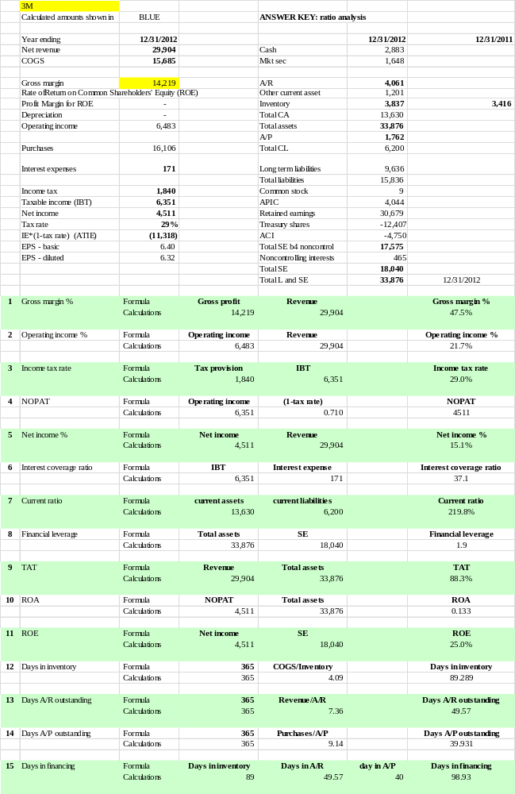

Limitations of ratio analysis
- Some ratios can be manipulated – if n/d>1, then (n-c)/(d-c) > n/d , where c is a constant
- Proportionality assumption (i.e., linearity of relations)
- Timing of the fiscal year
- Strategic actions/reporting by managers -- modifying ratios with making an equal change in both the numerator and denominator of a ratio
- Negative numbers
- Tied to GAAP requirements (e.g., limited definition of assets, historical costs, arbitrary cost allocations)
- Different accounting methods for different firms
- High correlation between ratios (contrast correlation with causation)
- Other factors affect magnitude of ratios and their changes other than the hypothesized effects (over time)

What are other ratios you think might be relevant in measuring the progress of a company like 3M that defines itself as an innovator?

